Establish a new directory, populate it with script files, initiate an empty repository on GitHub, convert the local directory into a Git repository, and link it to GitHub for pushing the code into the repository.

Initiate an empty repository on GitHub

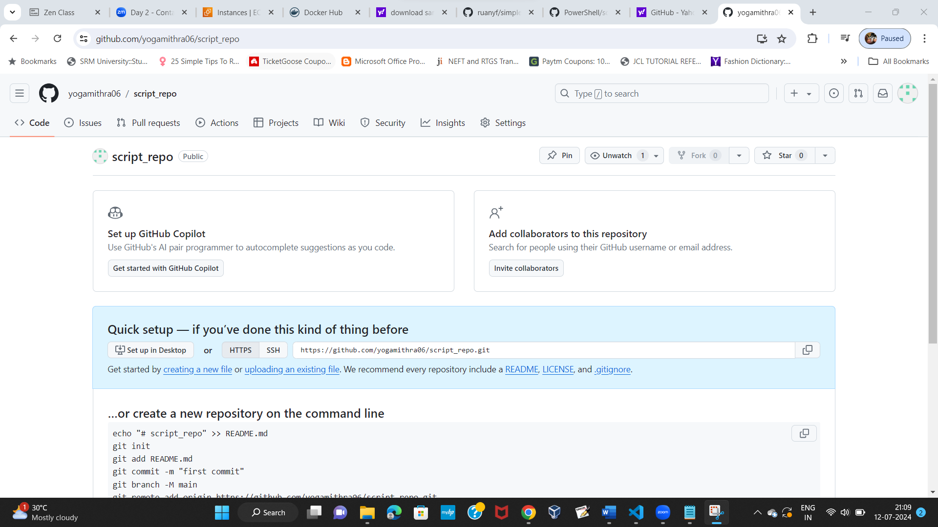

convert the local directory into a Git repository

git init

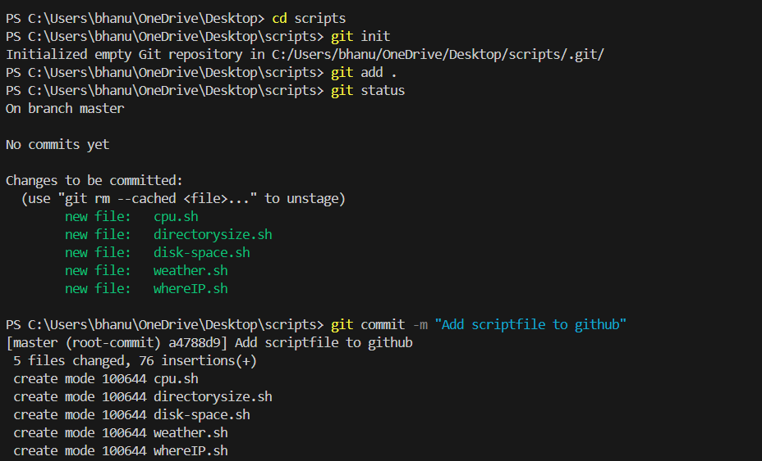

link it to GitHub for pushing the code into the repository

To link a local repository to a remote repository you can use the git remote add command followed by the name of the remote repository.

**Git remote add origin** https://github.com/yogamithra06/script_repo.git

